**Lab 1: Android Virtual Device (AVD)**

# **Introduction**

An Android Virtual Device (AVD), or emulator for Android, represents a particular Android device. To run and test our Android application on our PC, we can utilise the Android emulator as the target device. The Android emulator offers almost all of the features that a genuine smartphone would have.

We are able to take incoming calls and text messages. Additionally, it provides the device's location and simulates various network speeds. The Google Play store services, as well as other hardware sensors, can be accessed using the Android emulator, among other things.

**Let’s get Started**

This lab exercise will teach us about the Android Virtual Device (AVD). How to set up and launch an AVD using Android Studio.

Step 1: Click on Create Device Option from Device Manager Panel as shown below.

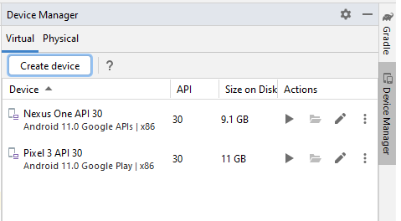

Step 2: Select a Device as per your requirement and click next.

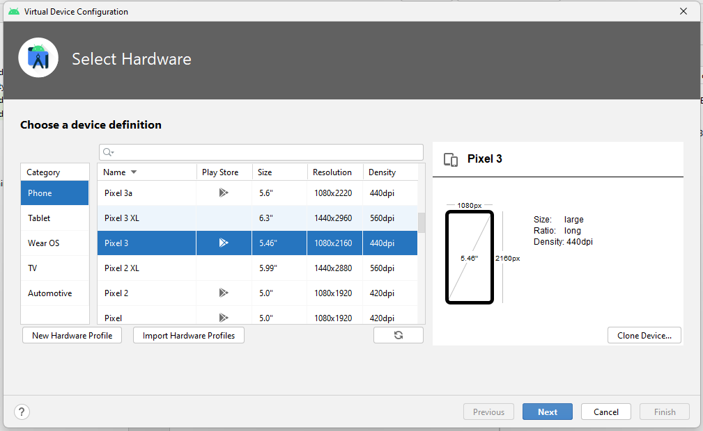

Step 3: Select a System Image and Install It.

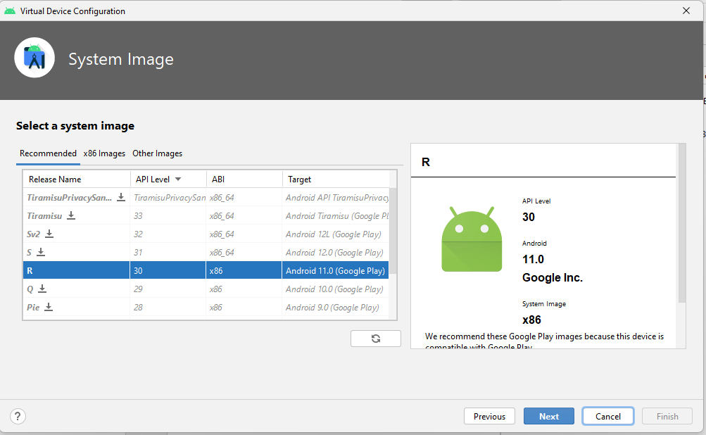

Step 4: Select an Orientation and Name your Device.

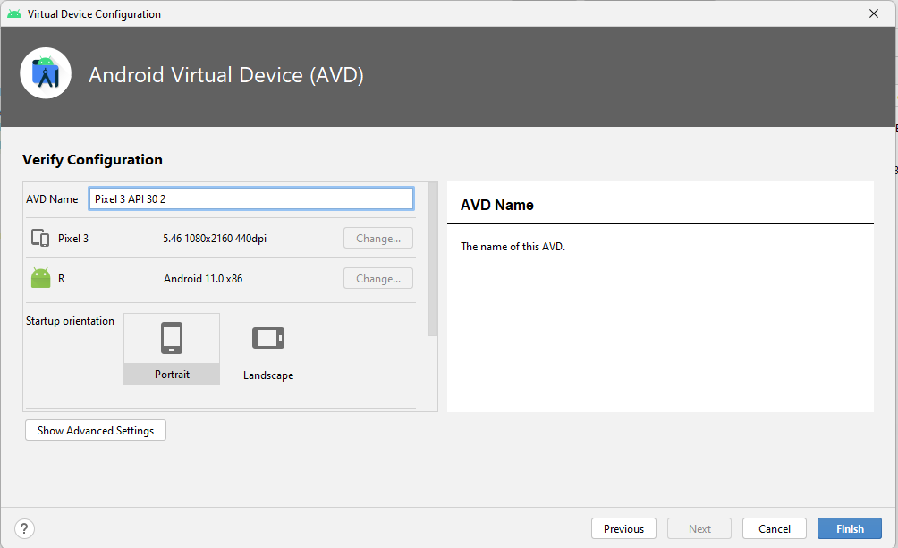

Step 5: Your Device will be visible in Device Manager Panel as shown below. Click on Play button to launch your AVD.

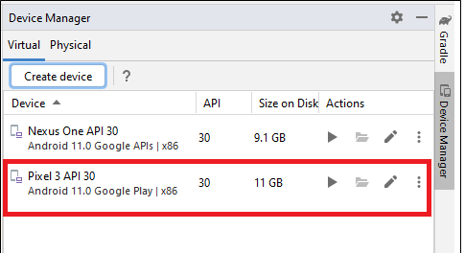

Step 6: Finally, Your Device will be started in Emulator Panel as shown below:

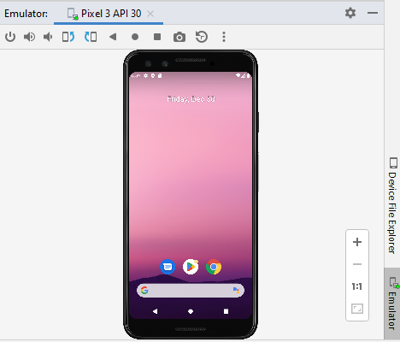

**Voila!!** We have successfully completed this lab.